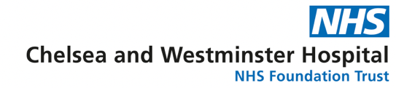
IBD and Ileoanal Pouch Surgery Centre – Application form for honorary placement

Overview
The Inflammatory Bowel Disease (IBD) and Ileoanal Pouch Surgery Centre at Chelsea and Westminster hospital in London provides all patients with a multidisciplinary approach, comprising IBD surgeons, gastroenterologists, radiologists, dietitians, and specialized nurses with high-level expertise in treatment of Crohn’s disease and Ulcerative colitis.
Chelsea and Westminster Hospital NHS Foundation Trust in London is a tertiary referral centre for Crohn’s disease and ileoanal pouch surgery. Our institution can boast of a high-volume service in minimally invasive surgery for primary and recurrent Crohn’s disease, Kono-S anastomosis technique, fistulating and perianal Crohn’s disease. Nonetheless, we have a high-volume practice in ileoanal “J-Pouch” surgery, performing primary and revisional ileoanal pouch surgery, and pouch excision.
The Ileoanal J-Pouch clinic is a multidisciplinary service offered to patients who have an ileoanal pouch or are considering having surgery. A dedicated pathway for these patients was developed at our J-Pouch one-stop clinic involving an endoscopic assessment of the pouch (pouchoscopy) and same-day meeting with our team of colorectal surgeons, gastroenterologists, IBD and stoma/pouch nurses. Our service also provides the chance for a “peer to peer counselling” thanks to a group of patients who previously had pouch surgery under our care and agreed to volunteer and share their precious experience and perspective.
In the dedicated J-Pouch clinic we evaluate conditions such as pouchitis, pouch dysfunction, pouch-anal and pouch-vaginal fistulae, increased bowel frequency, primary ileoanal pouch and redo pouch surgery, and surgical treatment of ulcerative colitis. The excellent care provided by the IBD and and Ileoanal Pouch Surgery Centre at our institution has been awarded nationally by the British Society of Gastroenterology.
Our IBD centre has a florid research and education activity, hosting national courses and leading on NIHR and multicentre studies. We also collaborate and place our experience at disposal of patients coming from other units, such as paediatric colorectal unit or endometriosis unit, joining our colleague to treat complex pediatric and endometriosis cases.
Thank you for your interest in joining our department, and welcome to the IBD and ileoanal pouch surgery Centre.
Valerio Celentano MD PhD FRCS – Consultant Colorectal Surgeon
Director IBD and Ileoanal Pouch surgery Centre – Chelsea and Westminster Hospital

Team Approach
Our IBD team takes pride in providing our patients with dedicated specialists collaborating to deliver the best care and the best outcomes.
The key components of the team include:
- Colorectal Surgeons
- Gastroenterologists
- Pediatric surgeons
- GI Pathologists
- GI Radiologists
- Clinical and Research fellows
- Specialist nurses in Inflammatory Bowel Disease
- Stoma nurse, Nurse Practitioners and Physician Assistants
Nutrition support, pain management and physical therapy are integrated in the patients’ pathway.
Educational offer
What to expect from your honorary period at Chelsea and Westminster Hospital:
- IBD surgery and colorectal service:
- High volume practice in Complex IBD surgery in a tertiary referral practice
- Weekly operating lists for complex Crohn’s and pouch surgery
- Weekly endoscopy lists for IBD and colorectal patients
- UK 1st “one-stop” Ileoanal pouch clinic and Young Adults Transition MDT
- Multidisciplinary care:
  - Weekly IBD MDT meeting
  - Weekly Oncology Colorectal MDT meeting
  - Monthly Northwest London Pouch MDT meeting
- Complex surgery for colorectal cancer, abdominal wall reconstruction.
- Audit and Quality Improvement
- Surgical Outcomes
- MDT activity audit
- PROMs
- Dedicated Patients pathways
- Research portfolio
- NIHR portfolio studies
- National/International studies
- Publications
- Training Courses
- Pouch Study Day course, annually held at Chelsea and Westminster Hospital
- Anastomosis in IBD course, annually held at Karl Storz Centre in Slough, London
- Proctoring programme
- Teaching and Leadership courses
- Collaboration with international fellows, observers, and medical students
- Webinars

- Paediatric Colorectal Surgery Collaboration
The department of paediatric and neonatal surgery at the Chelsea and Westminster Hospital provides specialist surgical services to the North-West London sector and a population of approx. 2 million of people. The department can count on 11 surgeons of which 2 are specialist paediatric colorectal surgeons supported by a senior paediatric colorectal fellow, a continence nurse specialist, and a neonatal surgical nurse specialist.
Opportunities for visiting fellows include:
- Twice weekly paediatric colorectal outpatient clinics
- Weekly paediatric colorectal MDT meeting (including colorectal transition MDT)
- Weekly paediatric surgical radiology MDT
- Weekly neonatal surgery MDT
- Weekly paediatric surgery teaching sessions
- Several paediatric surgery operating lists per week with exposure to complex pelvic and colorectal reconstruction including surgery for congenital anorectal malformations and Hirschprung’s disease.
- Weekly paediatric gastroenterology endoscpy lists for young onset IBD
- Opportunity to participate in clinical research and qualify improvement projects

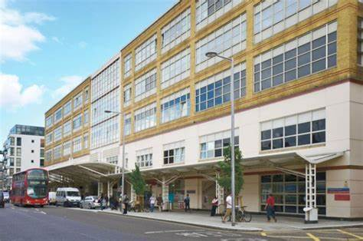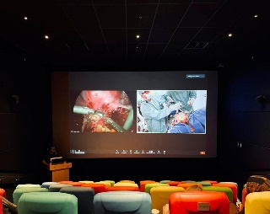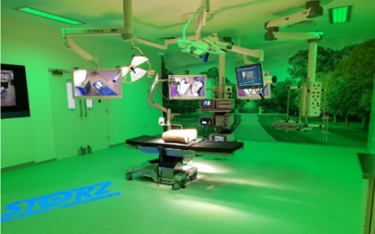
Open clinical and research positions

- Honorary Clinical Fellow
Minimum duration: 6 months (up to 12 months).
GMC registration required
Stated learning outcomes:
- Exposure to complex IBD surgery as first and second operator with operative logbook
- International research project participation and development
- MDT meeting exposure and participation
- Participation to the educational courses
Candidates are required to check their own VISA requirements for the placement. Clinical fellowships shorter than 6 months can be discussed on an individual basis.

- Observership
Duration: 2-4 weeks.
GMC registration not required.
Stated learning outcomes:
- Exposure to complex IBD surgery
- International research project participation and creation
- MDT meeting exposure and participation
- Participation to the educational courses
Candidates are required to check their own VISA requirements for the placement.

- Post-graduate degrees (MD, PhD)
Full time position for MD and PhD can be discussed on an individual basis according to the candidate’s interests.

Application form

Personal details:
Title:
First name:
Surname:
E-mail address:
Contact number:
Address:
Country:
Current working position and address:
GMC registered:
- Yes. If yes, please specify your GMC number: ________________
- No

Please attach a copy of your CV to this application form.

What type of placement are you interested in:
- Clinical fellowship (6 months minimum, up to 12 months)
- Observership (up to 4 weeks)
- Post-graduate degree

When would you like to start your placement:

Please describe your placement objectives and aims:

………………

Any other information you would like to provide:

………………

Please e-mail completed form to:

Contacts:
valerio.celentano@nhs.net
chelwest.j-pouch@nhs.net
Mr Valerio Celentano MD PhD FRCS
Consultant Colorectal Surgeon
Director – IBD and Ileoanal Pouch Surgery Centre
Chelsea and Westminster Hospitals NHS Foundation Trust

